Group 4 Project

Laura Larregui, Angela Garcia, John Christman

11/18/2019

readURL <- function(inputURL) #Begin function named readURL that takes a URL  
{  
 csvFile <- read.csv(url(inputURL), sep = ';') #assign the results of the URL call as a csv file to a dataframe named csvFile. Added sep = ';' to seperate the data into columns  
 return(csvFile) # return the dataframe  
}  
  
redWine <- readURL("https://archive.ics.uci.edu/ml/machine-learning-databases/wine-quality/winequality-red.csv")  
whiteWine <- readURL("https://archive.ics.uci.edu/ml/machine-learning-databases/wine-quality/winequality-white.csv")  
  
str(redWine)

## 'data.frame': 1599 obs. of 12 variables:  
## $ fixed.acidity : num 7.4 7.8 7.8 11.2 7.4 7.4 7.9 7.3 7.8 7.5 ...  
## $ volatile.acidity : num 0.7 0.88 0.76 0.28 0.7 0.66 0.6 0.65 0.58 0.5 ...  
## $ citric.acid : num 0 0 0.04 0.56 0 0 0.06 0 0.02 0.36 ...  
## $ residual.sugar : num 1.9 2.6 2.3 1.9 1.9 1.8 1.6 1.2 2 6.1 ...  
## $ chlorides : num 0.076 0.098 0.092 0.075 0.076 0.075 0.069 0.065 0.073 0.071 ...  
## $ free.sulfur.dioxide : num 11 25 15 17 11 13 15 15 9 17 ...  
## $ total.sulfur.dioxide: num 34 67 54 60 34 40 59 21 18 102 ...  
## $ density : num 0.998 0.997 0.997 0.998 0.998 ...  
## $ pH : num 3.51 3.2 3.26 3.16 3.51 3.51 3.3 3.39 3.36 3.35 ...  
## $ sulphates : num 0.56 0.68 0.65 0.58 0.56 0.56 0.46 0.47 0.57 0.8 ...  
## $ alcohol : num 9.4 9.8 9.8 9.8 9.4 9.4 9.4 10 9.5 10.5 ...  
## $ quality : int 5 5 5 6 5 5 5 7 7 5 ...

str(whiteWine)

## 'data.frame': 4898 obs. of 12 variables:  
## $ fixed.acidity : num 7 6.3 8.1 7.2 7.2 8.1 6.2 7 6.3 8.1 ...  
## $ volatile.acidity : num 0.27 0.3 0.28 0.23 0.23 0.28 0.32 0.27 0.3 0.22 ...  
## $ citric.acid : num 0.36 0.34 0.4 0.32 0.32 0.4 0.16 0.36 0.34 0.43 ...  
## $ residual.sugar : num 20.7 1.6 6.9 8.5 8.5 6.9 7 20.7 1.6 1.5 ...  
## $ chlorides : num 0.045 0.049 0.05 0.058 0.058 0.05 0.045 0.045 0.049 0.044 ...  
## $ free.sulfur.dioxide : num 45 14 30 47 47 30 30 45 14 28 ...  
## $ total.sulfur.dioxide: num 170 132 97 186 186 97 136 170 132 129 ...  
## $ density : num 1.001 0.994 0.995 0.996 0.996 ...  
## $ pH : num 3 3.3 3.26 3.19 3.19 3.26 3.18 3 3.3 3.22 ...  
## $ sulphates : num 0.45 0.49 0.44 0.4 0.4 0.44 0.47 0.45 0.49 0.45 ...  
## $ alcohol : num 8.8 9.5 10.1 9.9 9.9 10.1 9.6 8.8 9.5 11 ...  
## $ quality : int 6 6 6 6 6 6 6 6 6 6 ...

summary(redWine)

## fixed.acidity volatile.acidity citric.acid residual.sugar   
## Min. : 4.60 Min. :0.1200 Min. :0.000 Min. : 0.900   
## 1st Qu.: 7.10 1st Qu.:0.3900 1st Qu.:0.090 1st Qu.: 1.900   
## Median : 7.90 Median :0.5200 Median :0.260 Median : 2.200   
## Mean : 8.32 Mean :0.5278 Mean :0.271 Mean : 2.539   
## 3rd Qu.: 9.20 3rd Qu.:0.6400 3rd Qu.:0.420 3rd Qu.: 2.600   
## Max. :15.90 Max. :1.5800 Max. :1.000 Max. :15.500   
## chlorides free.sulfur.dioxide total.sulfur.dioxide  
## Min. :0.01200 Min. : 1.00 Min. : 6.00   
## 1st Qu.:0.07000 1st Qu.: 7.00 1st Qu.: 22.00   
## Median :0.07900 Median :14.00 Median : 38.00   
## Mean :0.08747 Mean :15.87 Mean : 46.47   
## 3rd Qu.:0.09000 3rd Qu.:21.00 3rd Qu.: 62.00   
## Max. :0.61100 Max. :72.00 Max. :289.00   
## density pH sulphates alcohol   
## Min. :0.9901 Min. :2.740 Min. :0.3300 Min. : 8.40   
## 1st Qu.:0.9956 1st Qu.:3.210 1st Qu.:0.5500 1st Qu.: 9.50   
## Median :0.9968 Median :3.310 Median :0.6200 Median :10.20   
## Mean :0.9967 Mean :3.311 Mean :0.6581 Mean :10.42   
## 3rd Qu.:0.9978 3rd Qu.:3.400 3rd Qu.:0.7300 3rd Qu.:11.10   
## Max. :1.0037 Max. :4.010 Max. :2.0000 Max. :14.90   
## quality   
## Min. :3.000   
## 1st Qu.:5.000   
## Median :6.000   
## Mean :5.636   
## 3rd Qu.:6.000   
## Max. :8.000

summary(whiteWine)

## fixed.acidity volatile.acidity citric.acid residual.sugar   
## Min. : 3.800 Min. :0.0800 Min. :0.0000 Min. : 0.600   
## 1st Qu.: 6.300 1st Qu.:0.2100 1st Qu.:0.2700 1st Qu.: 1.700   
## Median : 6.800 Median :0.2600 Median :0.3200 Median : 5.200   
## Mean : 6.855 Mean :0.2782 Mean :0.3342 Mean : 6.391   
## 3rd Qu.: 7.300 3rd Qu.:0.3200 3rd Qu.:0.3900 3rd Qu.: 9.900   
## Max. :14.200 Max. :1.1000 Max. :1.6600 Max. :65.800   
## chlorides free.sulfur.dioxide total.sulfur.dioxide  
## Min. :0.00900 Min. : 2.00 Min. : 9.0   
## 1st Qu.:0.03600 1st Qu.: 23.00 1st Qu.:108.0   
## Median :0.04300 Median : 34.00 Median :134.0   
## Mean :0.04577 Mean : 35.31 Mean :138.4   
## 3rd Qu.:0.05000 3rd Qu.: 46.00 3rd Qu.:167.0   
## Max. :0.34600 Max. :289.00 Max. :440.0   
## density pH sulphates alcohol   
## Min. :0.9871 Min. :2.720 Min. :0.2200 Min. : 8.00   
## 1st Qu.:0.9917 1st Qu.:3.090 1st Qu.:0.4100 1st Qu.: 9.50   
## Median :0.9937 Median :3.180 Median :0.4700 Median :10.40   
## Mean :0.9940 Mean :3.188 Mean :0.4898 Mean :10.51   
## 3rd Qu.:0.9961 3rd Qu.:3.280 3rd Qu.:0.5500 3rd Qu.:11.40   
## Max. :1.0390 Max. :3.820 Max. :1.0800 Max. :14.20   
## quality   
## Min. :3.000   
## 1st Qu.:5.000   
## Median :6.000   
## Mean :5.878   
## 3rd Qu.:6.000   
## Max. :9.000

#THe datasets only have one column of data. The column names are separated by periods the data by semi-colons  
#1. Create columns   
#2. separate the data into the columns  
#3. Verify no NAs  
redWine <- na.omit(redWine)  
whiteWine<-na.omit (whiteWine)

#1. Create visulaizations for the data  
#heat maps, histograms and scatter plots?  
  
#Heatmaps  
red_cor <- cor(redWine)  
white_cor <- cor(whiteWine)  
col<- colorRampPalette(c("blue", "white", "red"))(20)  
heatmap(x = red_cor, col = col, symm = TRUE)

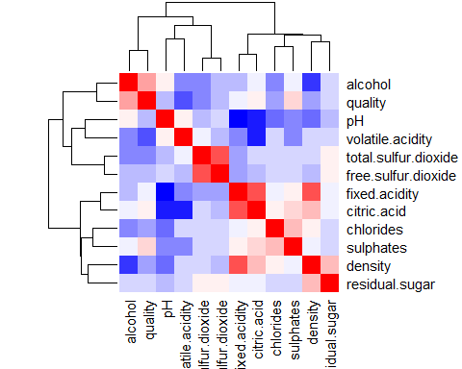

heatmap(x = white_cor, col = col, symm = TRUE)

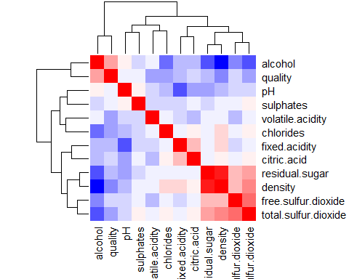

#Histograms  
hist(redWine$quality)

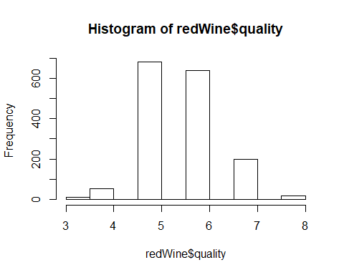

hist(whiteWine$quality)  
  
library(grid)

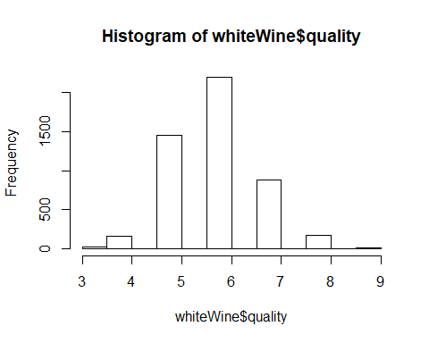

library(gridExtra)  
library (ggplot2)  
h1 <- ggplot(aes(density), data = redWine) + geom_histogram(bins = 30)   
  
h2 <- ggplot(aes(alcohol), data = redWine) + geom_histogram(bins = 30)  
  
h3 <- ggplot(aes(quality), data = redWine) + geom_histogram(bins = 7)  
  
  
grid.arrange(h1,h2,h3,ncol=2)

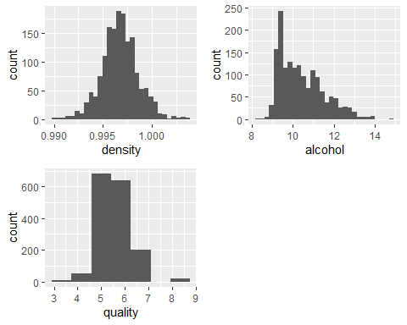

#1. Create the correlation matrix  
  
#Red Wine Correlation Matrix  
  
#install.packages("corrplot")  
library(corrplot)

## corrplot 0.84 loaded

red_cor <- cor(redWine)  
round(red_cor, 2)

## fixed.acidity volatile.acidity citric.acid  
## fixed.acidity 1.00 -0.26 0.67  
## volatile.acidity -0.26 1.00 -0.55  
## citric.acid 0.67 -0.55 1.00  
## residual.sugar 0.11 0.00 0.14  
## chlorides 0.09 0.06 0.20  
## free.sulfur.dioxide -0.15 -0.01 -0.06  
## total.sulfur.dioxide -0.11 0.08 0.04  
## density 0.67 0.02 0.36  
## pH -0.68 0.23 -0.54  
## sulphates 0.18 -0.26 0.31  
## alcohol -0.06 -0.20 0.11  
## quality 0.12 -0.39 0.23  
## residual.sugar chlorides free.sulfur.dioxide  
## fixed.acidity 0.11 0.09 -0.15  
## volatile.acidity 0.00 0.06 -0.01  
## citric.acid 0.14 0.20 -0.06  
## residual.sugar 1.00 0.06 0.19  
## chlorides 0.06 1.00 0.01  
## free.sulfur.dioxide 0.19 0.01 1.00  
## total.sulfur.dioxide 0.20 0.05 0.67  
## density 0.36 0.20 -0.02  
## pH -0.09 -0.27 0.07  
## sulphates 0.01 0.37 0.05  
## alcohol 0.04 -0.22 -0.07  
## quality 0.01 -0.13 -0.05  
## total.sulfur.dioxide density pH sulphates alcohol  
## fixed.acidity -0.11 0.67 -0.68 0.18 -0.06  
## volatile.acidity 0.08 0.02 0.23 -0.26 -0.20  
## citric.acid 0.04 0.36 -0.54 0.31 0.11  
## residual.sugar 0.20 0.36 -0.09 0.01 0.04  
## chlorides 0.05 0.20 -0.27 0.37 -0.22  
## free.sulfur.dioxide 0.67 -0.02 0.07 0.05 -0.07  
## total.sulfur.dioxide 1.00 0.07 -0.07 0.04 -0.21  
## density 0.07 1.00 -0.34 0.15 -0.50  
## pH -0.07 -0.34 1.00 -0.20 0.21  
## sulphates 0.04 0.15 -0.20 1.00 0.09  
## alcohol -0.21 -0.50 0.21 0.09 1.00  
## quality -0.19 -0.17 -0.06 0.25 0.48  
## quality  
## fixed.acidity 0.12  
## volatile.acidity -0.39  
## citric.acid 0.23  
## residual.sugar 0.01  
## chlorides -0.13  
## free.sulfur.dioxide -0.05  
## total.sulfur.dioxide -0.19  
## density -0.17  
## pH -0.06  
## sulphates 0.25  
## alcohol 0.48  
## quality 1.00

corrplot(red_cor, type = "upper", order = "hclust",   
 tl.col = "black", tl.srt = 45)

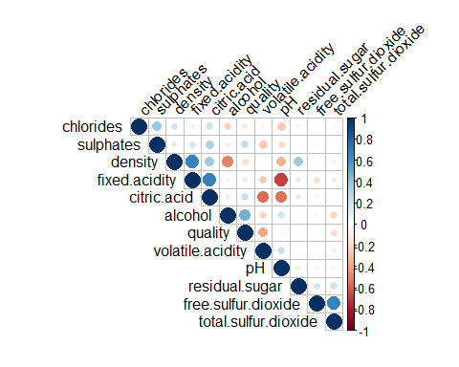

#Positive correlations are displayed in blue and negative correlations in red color. Color intensity and the size of the circle are proportional to the correlation coefficients.  
  
#Correlation matrix with numbers  
corrplot(red_cor, method = 'number', type = "upper", order = "hclust",   
 tl.col = "black", tl.srt = 45)

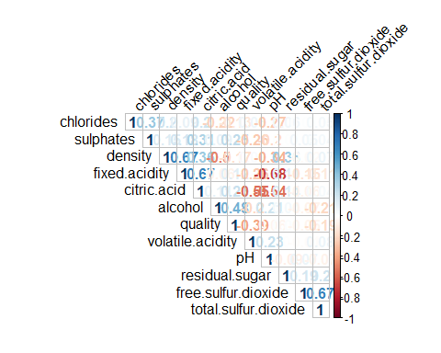

#White Wine Correlation Matrix  
  
#install.packages("corrplot")  
library(corrplot)  
white_cor <- cor(whiteWine)  
round(white_cor, 2)

## fixed.acidity volatile.acidity citric.acid  
## fixed.acidity 1.00 -0.02 0.29  
## volatile.acidity -0.02 1.00 -0.15  
## citric.acid 0.29 -0.15 1.00  
## residual.sugar 0.09 0.06 0.09  
## chlorides 0.02 0.07 0.11  
## free.sulfur.dioxide -0.05 -0.10 0.09  
## total.sulfur.dioxide 0.09 0.09 0.12  
## density 0.27 0.03 0.15  
## pH -0.43 -0.03 -0.16  
## sulphates -0.02 -0.04 0.06  
## alcohol -0.12 0.07 -0.08  
## quality -0.11 -0.19 -0.01  
## residual.sugar chlorides free.sulfur.dioxide  
## fixed.acidity 0.09 0.02 -0.05  
## volatile.acidity 0.06 0.07 -0.10  
## citric.acid 0.09 0.11 0.09  
## residual.sugar 1.00 0.09 0.30  
## chlorides 0.09 1.00 0.10  
## free.sulfur.dioxide 0.30 0.10 1.00  
## total.sulfur.dioxide 0.40 0.20 0.62  
## density 0.84 0.26 0.29  
## pH -0.19 -0.09 0.00  
## sulphates -0.03 0.02 0.06  
## alcohol -0.45 -0.36 -0.25  
## quality -0.10 -0.21 0.01  
## total.sulfur.dioxide density pH sulphates alcohol  
## fixed.acidity 0.09 0.27 -0.43 -0.02 -0.12  
## volatile.acidity 0.09 0.03 -0.03 -0.04 0.07  
## citric.acid 0.12 0.15 -0.16 0.06 -0.08  
## residual.sugar 0.40 0.84 -0.19 -0.03 -0.45  
## chlorides 0.20 0.26 -0.09 0.02 -0.36  
## free.sulfur.dioxide 0.62 0.29 0.00 0.06 -0.25  
## total.sulfur.dioxide 1.00 0.53 0.00 0.13 -0.45  
## density 0.53 1.00 -0.09 0.07 -0.78  
## pH 0.00 -0.09 1.00 0.16 0.12  
## sulphates 0.13 0.07 0.16 1.00 -0.02  
## alcohol -0.45 -0.78 0.12 -0.02 1.00  
## quality -0.17 -0.31 0.10 0.05 0.44  
## quality  
## fixed.acidity -0.11  
## volatile.acidity -0.19  
## citric.acid -0.01  
## residual.sugar -0.10  
## chlorides -0.21  
## free.sulfur.dioxide 0.01  
## total.sulfur.dioxide -0.17  
## density -0.31  
## pH 0.10  
## sulphates 0.05  
## alcohol 0.44  
## quality 1.00

corrplot(white_cor, type = "upper", order = "hclust",   
 tl.col = "black", tl.srt = 45)

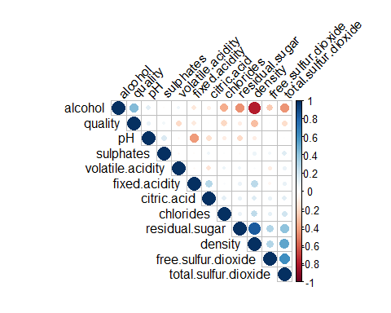

#Correlation matrix with numbers  
corrplot(white_cor, method = 'number',type = "upper", order = "hclust",   
 tl.col = "black", tl.srt = 45)

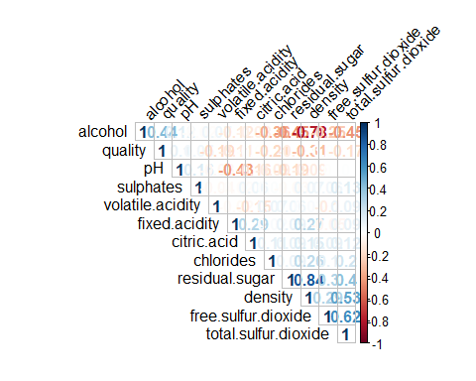

##Reference: http://www.sthda.com/english/wiki/correlation-matrix-a-quick-start-guide-to-analyze-format-and-visualize-a-correlation-matrix-using-r-software

#Machine learning techniques to see if we can train the system to pick a good wine